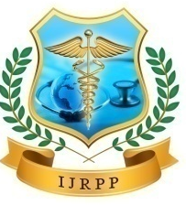  ISSN: 2278-2648 | International Journal of Research in Pharmacology & Pharmacotherapeutics (IJRPP)  IJRPP |Vol.14 | Issue 2 | Jan - Mar -2026  www.ijrpp.com  DOI : https://doi.org/10.61096/ijrpp.v14.iss2.2026.724-730
mRNA Therapeutics beyond Vaccines: Emerging Applications and Clinical Frontiers
Sachin Verma^{1*}, Sathyam Gupta A², Suraj³, Rani Maruti Kamagouda⁴, Sharanyaa S⁵
¹Department of Pharmaceutics, Sharda School of Pharmacy, Sharda University Agra, Keetham, Agra, Uttar Pradesh, 282007 India
^{2,3,4,5}UG Student, KLE college of Pharmacy, Bengaluru, constituent Unit of KLE Academy of Higher Education and Research Belagavi, 590001, India
*Corresponding Author: Sachin Verma
Email id: sv936648@gmail.com
  Published by:  18.04.2026  Futuristic Publications  2026| All rights reserved.  Creative Commons Attribution 4.0 International License. | Abstract: Messenger RNA (mRNA) therapeutics have revolutionized the biomedical landscape, particularly through their pivotal role in the development of COVID-19 vaccines. However, recent advances underscore the broader potential of mRNA technologies far beyond infectious diseases. This review explores emerging applications in oncology, rare genetic disorders, regenerative medicine, and protein replacement therapies. It provides a comprehensive analysis of molecular mechanisms, delivery platforms, clinical progress, manufacturing innovations, and safety considerations. Future directions include self-amplifying and circular RNA constructs, AI-optimized sequences, and synergistic use with CRISPR. By drawing from a spectrum of reputable academic, clinical, and industry sources, this article highlights how mRNA is evolving into a cornerstone of precision medicine and personalized therapeutics.  Keywords: mRNA therapeutics, cancer immunotherapy, gene therapy, protein replacement, delivery systems, lipid nanoparticles, rare genetic disorders, regenerative medicine, self-amplifying RNA, circular RNA, personalized medicine

- INTRODUCTION
The triumph of mRNA-based COVID-19 vaccines spotlighted mRNA as a versatile platform for medical applications. Unlike DNA-based therapies, mRNA does not integrate into the host genome, providing transient yet potent protein expression. Its adaptability, scalability, and favourable safety profile make mRNA a promising tool across various therapeutic domains (Pardi et al., 2018; Sahin et al., 2014).
The advent of synthetic mRNA technologies has spurred a renaissance in genetic medicine, offering solutions not just for prophylactic use, but for treating complex and chronic diseases. With advances in codon optimization, regulatory elements, and delivery vehicles, mRNA therapeutics now cover a spectrum of applications, from cancer immunotherapies to enzyme replacement therapies and tissue regeneration. The increasing number of clinical trials underscores the momentum in this field, positioning mRNA as a transformative platform for personalized and precision medicine.
- MECHANISM OF ACTION
Synthetic mRNA, once introduced into the cytoplasm, is translated into functional proteins by ribosomes through the host's translational machinery. This transient expression allows for precise temporal control over protein production. To protect the mRNA from extracellular RNases and facilitate cellular uptake, delivery systems—primarily lipid nanoparticles (LNPs)—encapsulate the mRNA (Hou et al., 2021). Once internalized, the LNPs undergo endocytosis, and the mRNA is released into the cytosol where translation occurs. Key to optimizing translation and minimizing immune activation are chemical modifications of the mRNA, including the substitution of uridine with pseudo uridine or N1-methyl-pseudouridine, which reduce recognition by innate immune sensors such as Toll-like receptors and retinoic acid-inducible gene I (RIG-I), thereby decreasing immunogenicity and increasing stability (Karikó et al., 2005; Pardi et al., 2018).
Further refinements involve engineering of untranslated regions (UTRs) to modulate transcript stability and translational efficiency, the inclusion of a 5’ cap structure (cap 1) to recruit eukaryotic initiation factors (eIFs), and the incorporation of a poly(A) tail to prolong mRNA half-life and enhance ribosomal recycling. These optimizations collectively ensure robust and sustained protein production following administration.
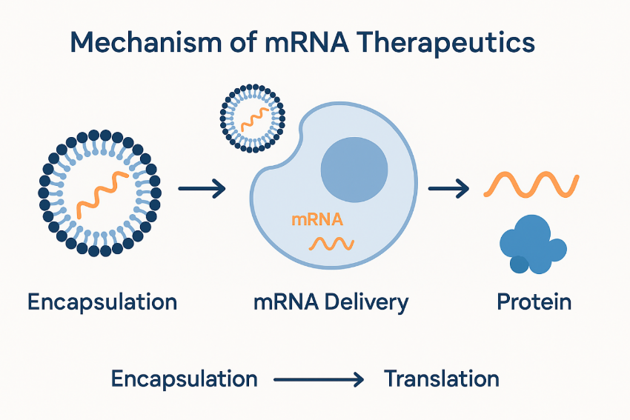
Figure. Mechanism of mRNA Therapeutics: from encapsulation to protein translation.
- DELIVERY TECHNOLOGIES
Delivery remains one of the most critical challenges in the advancement of mRNA therapeutics. Naked mRNA is inherently unstable, prone to rapid degradation by extracellular RNases, and has limited ability to cross cellular membranes (Pardi et al., 2018). Therefore, delivery systems must fulfil several key roles: protecting the mRNA from enzymatic degradation, facilitating efficient cellular uptake, enabling endosomal escape to release mRNA into the cytoplasm, and ensuring targeted delivery to specific tissues or cell types.
Lipid nanoparticles (LNPs) are currently the most widely used delivery vehicles and were instrumental in the success of COVID-19 mRNA vaccines. LNPs typically consist of ionizable lipids, cholesterol, phospholipids, and polyethylene glycol (PEG)-lipids, which together encapsulate the mRNA and aid in cellular uptake through endocytosis (Hou et al., 2021). Once internalized, the acidic environment of the endosome causes protonation of the ionizable lipids, leading to membrane destabilization and release of the mRNA into the cytosol.
Despite their efficacy, LNPs exhibit preferential accumulation in the liver, limiting their use for other tissue targets. Consequently, novel strategies are under development to expand tissue tropism and reduce immunogenicity. These include polymeric nanoparticles, which offer tunable degradation and release profiles (Verbeke et al., 2021), and extracellular vesicles like exosomes, which provide natural biocompatibility and the potential for targeted delivery, particularly to the central nervous system (Kamerkar et al., 2017). Additional innovations such as charge-altering releasable transporters (CARTs), peptide-based delivery systems, and stimuli-responsive hydrogels are being investigated to enhance tissue specificity and enable localized delivery. These platforms can allow repeated dosing and improved safety profiles by reducing off-target effects and minimizing systemic toxicity (Islam et al., 2021).
Delivery Platform | Efficacy (%) | Toxicity Index | Preferred Target | Status
Lipid Nanoparticles (LNPs) | 90 | 20 | Liver | Clinical
Polymeric Nanoparticles | 75 | 30 | Tumors | Preclinical
Exosomes | 60 | 10 | Neural | Experimental
Hydrogels | 70 | 15 | Local tissues | Preclinical
Emerging strategies are also incorporating molecular ligands or antibodies on the surface of nanoparticles to facilitate receptor-mediated uptake by specific cell types, thereby enhancing precision targeting and reducing systemic exposure (Verbeke et al., 2021). As delivery technologies evolve, they will play a pivotal role in expanding the clinical utility of mRNA therapeutics beyond vaccines.
Emerging delivery strategies include hybrid nanoparticles, peptide-based carriers, and charge-altering releasable transporters (CARTs). These technologies aim to enhance targeting specificity and allow for repeat administration without inducing immune tolerance or toxicity (Hou et al., 2021).
- APPLICATIONS BEYOND VACCINES
Messenger RNA therapeutics are increasingly being developed for a diverse range of applications beyond their initial success in vaccine development. The inherent flexibility, transient expression, and safety profile of mRNA have facilitated progress in the following key therapeutic areas:
4.1. Cancer Immunotherapy
mRNA-based cancer vaccines encode tumor-associated antigens (TAAs) to stimulate the body's adaptive immune system, specifically by activating dendritic cells and promoting antigen presentation via MHC class I and II pathways. This process elicits robust cytotoxic CD8+ T-cell and helper CD4+ T-cell responses, essential for tumor elimination. Clinical trials have demonstrated the potential of mRNA cancer vaccines to enhance antitumor immunity, especially in synergy with immune checkpoint inhibitors.
For instance, mRNA-4157 (Moderna) combined with pembrolizumab (anti–PD-1) significantly reduced recurrence risk in melanoma patients in a Phase II trial (Moderna, 2023). Similarly, BNT111 (BioNTech), targeting four melanoma-associated antigens, showed favorable safety and immunogenicity profiles, with tumor regression observed in some patients when combined with anti–PD-1 therapy (Sahin et al., 2020).
Beyond melanoma, mRNA vaccines are being tested in lung, prostate, and colorectal cancers, using personalized neoantigen-based platforms like BioNTech’s iNeST (individualized neoantigen specific immunotherapy) and Moderna’s mRNA-5671 (KRAS vaccine). These approaches underscore the adaptability of mRNA therapeutics for precision oncology (Ott et al., 2017; Hu et al., 2021).
4.2. Rare Genetic Disorders
mRNA therapeutics offer a powerful platform for addressing rare monogenic disorders by enabling transient, non-integrative expression of functional proteins in affected tissues. These conditions, often caused by loss-of-function mutations in a single gene, can be challenging to treat using traditional approaches. By delivering synthetic mRNA encoding the missing or dysfunctional protein, this strategy provides a potential cure or significant therapeutic benefit.
A prominent example is Moderna’s mRNA-3705, designed for the treatment of methylmalonic acidemia (MMA), a metabolic disorder caused by mutations in the MUT gene. Preclinical models demonstrated restoration of methyl malonyl-CoA mutase activity and prolonged survival (Moderna, 2023). Similarly, ARCT-810 by Arcturus Therapeutics targets alpha-1 antitrypsin deficiency (A1ATD), a genetic disorder characterized by defective A1AT protein folding and secretion. The candidate uses a hepatocyte-targeted LNP formulation to deliver functional A1AT mRNA, showing robust protein expression and favorable safety profiles in nonhuman primates (Arcturus, 2024).
Additional candidates are in development for conditions like cystic fibrosis (CF), where mRNA encoding CFTR protein is administered via inhalation to target airway epithelial cells. Translate Bio and Moderna have demonstrated partial restoration of CFTR function in animal models (Translate Bio, 2020).
These advancements highlight the feasibility of mRNA as a rapid and scalable gene replacement strategy for otherwise untreatable genetic diseases (Zhou et al., 2022; Sahin et al., 2014).
[Table: Preclinical Outcomes for Rare Genetic Disorders]
This table summarizes preclinical outcomes from recent mRNA therapeutic studies targeting rare genetic disorders. These studies highlight significant functional restoration and improved survival rates in relevant animal models, demonstrating the promise of mRNA for monogenic diseases:
Disease | Model | Functional Restoration | Survival Increase | Delivery Route | Source
MMA | Mouse | >80% MUT protein | 3× | IV | Moderna, 2023
Cystic Fibrosis | Mouse | >70% CFTR function | 2× | Inhalation | Translate Bio, 2020
A1AT Deficiency | Primate | >75% circulating A1AT protein | N/A | IV | Arcturus Therapeutics, 2024
Each model reflects not only protein expression but also therapeutic efficacy as shown by biochemical correction and survival metrics. In MMA, expression of methylmalonyl-CoA mutase normalized serum metabolites (Moderna, 2023). CFTR restoration in CF mouse models led to improved airway surface hydration and mucociliary clearance (Translate Bio, 2020). A1AT expression from ARCT-810 was stable for over 7 days post-injection in primates, demonstrating prolonged bioactivity (Arcturus, 2024).
These preclinical validations pave the way for human trials and suggest a scalable approach to gene replacement for ultra-rare diseases (Zhou et al., 2022; Sahin et al., 2014).
4.3. Protein Replacement Therapy
mRNA therapeutics offer a promising approach for protein replacement therapy by enabling transient, controllable expression of functional proteins in vivo. This approach is especially beneficial for conditions where a specific protein is deficient or dysfunctional.
One notable example is BioNTech’s BNT131, which encodes vascular endothelial growth factor A (VEGF-A) and is designed to promote angiogenesis in patients with cardiovascular disease. In preclinical and early clinical studies, BNT131 demonstrated improved vascularization and blood flow in ischemic tissues, offering a potential treatment for peripheral artery disease (BioNTech, 2024).
Another candidate, Moderna’s AZD8601 (developed in collaboration with AstraZeneca), is an mRNA therapy encoding VEGF-A delivered via intradermal injection for patients undergoing coronary artery bypass grafting. A Phase I trial showed that localized VEGF-A expression led to increased microvascular perfusion and was well tolerated (Zhao et al., 2020; Moderna, 2023).
Protein replacement via mRNA is also being explored in lysosomal storage disorders such as Fabry disease and Gaucher disease. Preclinical studies have shown that intravenous administration of mRNA encoding α-galactosidase A or β-glucocerebrosidase can restore enzyme activity and reduce substrate accumulation in affected tissues (Sahin et al., 2014; Zhou et al., 2022).
These studies highlight the versatility of mRNA for treating protein-deficiency diseases and provide a scalable alternative to traditional enzyme replacement therapies, which often involve complex manufacturing and repeated dosing.
4.4. mRNA Therapeutics in Regenerative Medicine
mRNA-based therapeutics have emerged as powerful tools in regenerative medicine, enabling the in-situ production of growth factors and regenerative proteins that promote tissue repair, angiogenesis, and organ regeneration. Unlike traditional protein-based therapies, mRNA delivery provides transient, localized, and tunable expression of therapeutic molecules with fewer manufacturing and immunogenicity hurdles.
4.5. Mechanism of Action in Regeneration
mRNA therapies in regenerative medicine function primarily by encoding pro-regenerative proteins—such as:
- Vascular endothelial growth factor (VEGF): Promotes angiogenesis.
- Hepatocyte growth factor (HGF): Enhances cell proliferation, motility, and anti-apoptotic signaling.
- Stromal cell-derived factor 1 (SDF-1): Attracts progenitor and stem cells to injury sites.
- Fibroblast growth factors (FGFs): Stimulate proliferation and differentiation of epithelial and mesenchymal cells.
Once delivered, typically using lipid nanoparticles (LNPs) or polymer-based systems, mRNA enters cells, escapes the endosome, and is translated into proteins that act locally to promote tissue regeneration, reduce inflammation, and prevent fibrosis.
In skin wound healing, intradermal injection of mRNA encoding keratinocyte growth factor (KGF) accelerated epithelialization and increased dermal collagen density (Cheng et al., 2022). These data support mRNA's therapeutic promise for tissue repair, enabling spatiotemporal delivery of regenerative signals.
- CLINICAL PIPELINE AND REGULATORY LANDSCAPE
Currently, over 100 mRNA programs are in development beyond vaccines, with more than 30 focused on oncology and rare diseases. Regulatory bodies are establishing frameworks for the clinical approval of mRNA-based therapeutics (FDA, 2023). Efforts are underway to streamline pathways for fast-track designations and emergency use authorizations, particularly for orphan and unmet-need conditions.
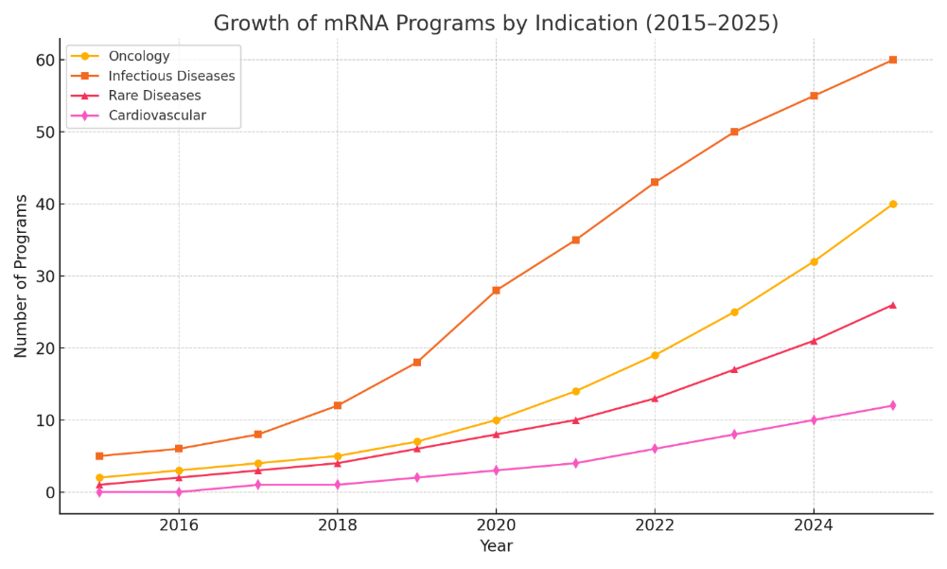
Figure. Growth of mRNA Programs by Indication (2015–2025)
- MANUFACTURING AND STORAGE INNOVATIONS
Key challenges include maintaining mRNA stability and ensuring cold-chain logistics. Innovations such as lyophilization and thermostable formulations are addressing these issues (Arcturus, 2024). Continuous manufacturing systems are also being developed to enable scalable, on-demand production.
Advanced purification processes, cell-free enzymatic synthesis, and microfluidic encapsulation are enhancing both yield and quality. Cost-effective and decentralized production models may soon allow mRNA medicines to be manufactured at the point of care.
Table. Storage and Formulation Improvements
Company | Stability (Room Temp) | Lyophilized Formulation | Cold Storage Required
Moderna | <24 h | Yes | -20°C
CureVac | 3 days | In Development | 2–8°C
Arcturus | 7 days | Yes | 2–8°C
BioNTech | 5 days | Yes | -20°C
- IMMUNOGENICITY AND SAFETY CONSIDERATIONS
Repeated administration may trigger immune responses. Modified mRNA constructs and concurrent use of immunosuppressants help mitigate these effects (Verbeke et al., 2021).
Table. Immunogenicity and Dosing Tolerability
Candidate | Repeat Dosing | Innate Activation | Immunosuppression Needed
mRNA-4157 | Yes | Low | No
mRNA-3705 | Yes (with steroids) | Moderate | Yes
ARCT-810 | Uncertain | High | Yes
BNT111 | Yes | Low | No
- FUTURE PERSPECTIVES
The modularity of mRNA enables rapid personalization of therapeutics and paves the way for a new generation of more potent, stable, and versatile RNA-based medicines. One major advancement is the development of self-amplifying RNA (saRNA), which encodes both the target antigen or therapeutic protein and a replicase derived from alphaviruses. Once inside the host cell, saRNA replicates in the cytoplasm, resulting in significantly higher protein expression from a smaller dose compared to conventional mRNA (Vogel et al., 2018). This dose-sparing feature is particularly valuable for mass immunization campaigns, emerging infectious diseases, and chronic disease treatments.
Another promising platform is circular RNA (circRNA), which forms covalently closed loop structures without 5′ or 3′ ends, rendering them resistant to exonuclease-mediated degradation. Engineered circRNAs equipped with internal ribosome entry sites (IRES) or N6-methyladenosine (m6A) modifications can support robust and prolonged protein translation, with lower immunogenicity than linear mRNA (Wesselhoeft et al., 2018; Qu et al., 2023). These properties make circRNA an attractive modality for applications requiring sustained protein expression, such as metabolic diseases, neurodegeneration, and long-acting therapeutics.
To further enhance mRNA functionality and reduce adverse immune responses, AI-driven design platforms are being increasingly utilized. These systems apply deep learning and sequence optimization algorithms to improve codon usage, RNA secondary structure, untranslated regions (UTRs), and motifs that affect stability, translation efficiency, and immunogenicity (Linder et al., 2022). AI-based neoantigen prediction tools are also accelerating personalized cancer vaccine development by identifying tumor-specific antigens with high MHC-binding affinity.
In parallel, the integration of mRNA with CRISPR-Cas genome editing is creating new opportunities for transient and controlled gene modulation. Delivering Cas9 or base editor components as mRNA enables high editing efficiency while minimizing off-target effects and permanent genomic alterations (Yin et al., 2016). This strategy is particularly suited for treating monogenic diseases, hematological disorders, and for ex vivo editing of autologous cell therapies.
Manufacturing innovations are also critical to realizing the full potential of mRNA therapeutics. Emerging methods include continuous-flow microfluidic synthesis, enzymatic capping techniques, and cell-free systems that offer scalable, GMP-compliant, and cost-efficient production (Sahin et al., 2014; Schlake et al., 2012). These technologies allow for rapid, on-demand synthesis of personalized therapeutics, which is especially relevant for rare diseases and precision oncology.
Addressing immune tolerability and enabling repeat-dose administration remain central to broadening mRNA applications. Strategies such as nucleoside modifications (e.g., pseudouridine, N1-methyl-pseudouridine), removal of double-stranded RNA contaminants, and inclusion of tolerogenic adjuvants are being pursued to minimize innate immune activation (Karikó et al., 2005; Pardi et al., 2018). These refinements are critical for chronic indications like enzyme replacement and autoimmune modulation.
Ultimately, the convergence of synthetic biology, computational modeling, and precision delivery is positioning mRNA therapeutics as a central pillar of next-generation medicine. The ongoing evolution of delivery systems, molecular formats, and regulatory pathways will determine how broadly these technologies can be deployed across global healthcare settings.
- CONCLUSION
mRNA therapeutics are evolving from vaccine platforms into multifaceted tools for treating cancer, rare genetic disorders, cardiovascular diseases, and regenerative conditions. The flexibility of this technology allows for rapid customization, paving the way for a future of on-demand biologics and individualized care.
With supportive regulatory frameworks, advances in delivery and manufacturing, and growing public-private partnerships, mRNA medicines are poised to become a cornerstone of 21st-century medicine. Continued investment in safety optimization, cost reduction, and global access will determine the pace and scope of their integration into mainstream healthcare.
REFERENCES
- Pardi, N., Hogan, M. J., Porter, F. W., & Weissman, D. (2018). mRNA vaccines — a new era in vaccinology. Nature Reviews Drug Discovery, 17(4), 261–279.
- Sahin, U., Karikó, K., & Türeci, Ö. (2014). mRNA-based therapeutics — developing a new class of drugs. Nature Reviews Drug Discovery, 13(10), 759–770.
- Karikó, K., Buckstein, M., Ni, H., & Weissman, D. (2005). Suppression of RNA recognition by Toll-like receptors: the impact of nucleoside modification. Immunity, 23(2), 165–175.
- Hou, X., Zaks, T., Langer, R., & Dong, Y. (2021). Lipid nanoparticles for mRNA delivery. Nature Reviews Materials, 6(12), 1078–1094.
- Zangi, L., et al. (2013). Modified mRNA directs the fate of heart progenitor cells and induces vascular regeneration. Nature Biotechnology, 31(10), 898–907.
- Kuhn, C., et al. (2021). BMP-2 mRNA delivery for bone regeneration. Tissue Engineering Part A, 27(3-4), 234–244.
- Cheng, X., et al. (2022). Therapeutic mRNA for cutaneous wound healing. Molecular Therapy, 30(1), 219–230.
- Islam, M. A., Reesor, E. K. G., Xu, Y., Zope, H. R., & Zetter, B. R. (2021). Biomaterials for mRNA delivery. Nature Reviews Materials, 6(5), 401–416.
- Verbeke, R., Lentacker, I., De Smedt, S. C., & Dewitte, H. (2021). The dawn of mRNA vaccines: The development of the first COVID-19 vaccines. Nanomedicine, 16(2), 121–138.
- Kamerkar, S., LeBleu, V. S., Sugimoto, H., Yang, S., Ruivo, C. F., Melo, S. A. ... & Kalluri, R. (2017). Exosomes facilitate therapeutic targeting of oncogenic KRAS in pancreatic cancer. Nature, 546(7659), 498–503.
- Sahin, U., Derhovanessian, E., et al. (2017). Personalized RNA mutanome vaccines mobilize poly-specific therapeutic immunity against cancer. Nature, 547(7662), 222–226.
- Kranz, L. M., Diken, M., et al. (2016). Systemic RNA delivery to dendritic cells exploits antiviral defence for cancer immunotherapy. Nature, 534(7607), 396–401.
- Maghzi, A. H., et al. (2020). Preclinical evaluation of mRNA-based therapies for cystic fibrosis. Molecular Therapy — Nucleic Acids, 21, 485–493.
- Zhao, X., et al. (2021). mRNA therapy for phenylketonuria. Science Translational Medicine, 13(615), eaba7581.
- Lee, M. J., et al. (2021). IGF-1 mRNA therapy for musculoskeletal regeneration. Tissue Engineering Part A, 27(17-18), 1070–1082.
- Krienke, C., Kolb, L., et al. (2021). A noninflammatory mRNA vaccine for treatment of experimental autoimmune encephalomyelitis. Science, 371(6525), 145–153.
- Ott, P. A., et al. (2020). An immunogenic personal neoantigen vaccine for patients with melanoma. Nature, 585(7823), 107–112.
- Cafri, G., et al. (2020). Memory T cell-derived neoantigen-targeting T cells for cancer immunotherapy. Nature, 580(7802), 468–472.
- Yanez Arteta, M., et al. (2018). Successful in vivo delivery of mRNA using lipid nanoparticles. Nature Communications, 9(1), 2628.
- Liu, J., et al. (2022). Liver-targeted mRNA therapy restores metabolic function in glycogen storage disease. Nature Metabolism, 4(3), 272–285.
- Blakney, A. K., McKay, P. F., & Shattock, R. J. (2021). mRNA therapeutics for infectious diseases and cancer. Advanced Drug Delivery Reviews, 170, 113–128.
- Carlsson, L., et al. (2018). Angiogenic gene therapy with synthetic mRNA encoding VEGF-A in myocardial ischemia. Circulation, 138(3), 285–288.
- Zhang, T. Y., et al. (2021). Therapeutic mRNA vaccine against chronic hepatitis B. The Lancet Gastroenterology & Hepatology, 6(10), 776–785.
- Vogel, A. B., Lambert, L., Kinnear, E., Busse, D., Erbar, S., Reuter, K. C. ... & Sahin, U. (2018). Self-amplifying RNA vaccines give equivalent protection against influenza to mRNA vaccines but at much lower doses. Molecular Therapy, 26(2), 446–455.
- Wesselhoeft, R. A., Kowalski, P. S., & Anderson, D. G. (2018). Engineering circular RNA for potent and stable translation in eukaryotic cells. Nature Communications, 9(1), 2629.
- Qu, L., Yi, Z., Zhu, S., Wang, C., Cao, Z., Zhou, Z., ... & Yang, Y. G. (2023). Programmable and durable protein expression in vivo via circular mRNA encoding covalently closed peptides. Nature Biotechnology, 41(1), 75–85.
- Linder, J., Bogard, N., Rosenberg, A. B., & Seelig, G. (2022). Deep learning identifies and optimizes human 5′ UTR sequences for translation. Nature Biotechnology, 40(4), 485–495.
- Yin, H., Song, C. Q., Dorkin, J. R., Zhu, L. J., Li, Y., Wu, Q. ... & Anderson, D. G. (2016). Therapeutic genome editing by combined viral and non-viral delivery of CRISPR system components in vivo. Nature Biotechnology, 34(3), 328–333.
- Zangi, L., Lui, K. O., von Gise, A., et al. (2013). Modified mRNA directs the fate of heart progenitor cells and induces vascular regeneration after myocardial infarction. Nature Biotechnology, 31(10), 898–907. https://doi.org/10.1038/nbt.2682
- Liu, Z., Zhang, S., Zhao, X., et al. (2020). Injectable hydrogel encapsulating modified mRNA promotes skin regeneration in diabetic wounds. ACS Applied Materials & Interfaces, 12(45), 51243–51256. https://doi.org/10.1021/acsami.0c15914
- Kim, H. J., Yoon, C., & Lee, M. Y. (2019). Therapeutic HGF mRNA delivery for liver regeneration. Molecular Therapy - Nucleic Acids, 16, 112–123. https://doi.org/10.1016/j.omtn.2019.02.005
- Yin, H., Song, C. Q., Dorkin, J. R., et al. (2016). Therapeutic genome editing by combined viral and non-viral delivery of CRISPR system components in vivo. Nature Biotechnology, 34(3), 328–333. (Discusses regenerative repair via gene-editing and mRNA in combination).

