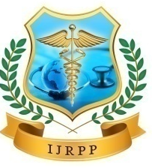
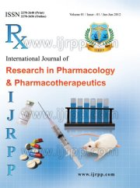
International Journal of Research in Pharmacology & Pharmacotherapeutics
ISSN Print: 2278-2648 IJRPP |Vol.5 | Issue 4 | Oct - Dec - 2016
ISSN Online: 2278-2656 Journal Home page: www.ijrpp.com

Research article Open Access

A new looming of Middle East respiratory syndrome coronavirus MERS-CoV

Mehta Shachi*
Scientifique-Chercheur, PBS INSERM U1070, Université de Poitiers, France
Masters of Pharmacy, A-one college of Pharmacy, Gujarat Technological University, India.
*Corresponding author: Mehta Shachi

ABSTRACT
Middle East Respiratory Syndrome Coronavirus is the species of genus Beta Coronavirus. A novel human coronaviruses are single-stranded RNA. They are distinct from SARS and common cold viruses. First case of MERS-CoV was reported in Saudi Arabia in April 2012, in patients with severe Pneumonia. MERS-CoV has mild to non-specific symptoms which includes Headache, vomiting, High fever, cough, etc. MERS-CoV has been reported under high mortality rate. It is diagnosed through PCR (Polymerase Chain Reaction) and virus isolation from respiratory tracts and blood samples. No Antiviral agents or vaccines are available for this disease.
Keywords: Middle East Respiratory Syndrome Coronavirus, MERS-CoV, Sign and symptoms, Diagnosis, Precaution, Treatment

INTRODUCTION
Coronaviruses (CoV) are crown like spikes and single-stranded RNA viruses which are mainly responsible for respiratory disease in animals and humans. Globally there are four different types of human coronavirus (hCoV): alpha, Beta, delta and gamma, which are known for spectrum of agents causing common cold. During 2002 and 2003, there was a novel human coronavirus, which was responsible for causing severe acute Respiratory syndrome (SARS) and affected approximate 8,000 people globally. Fatality rate was 10%. Symptoms were similar to acute primary viral pneumonia, known as severe acute respiratory syndrome (SARS) [0]. Coronaviruses are distributed widely in humans, animals, mammals, birds, etc. hCoVs can be transmitted through direct or indirect contact with secretions. Virus is excreted in faeces and urine by infected patients and can infect other people. This virus also can be transmitted via airborne transmission from aerosolized respiratory secretions and faecal material.

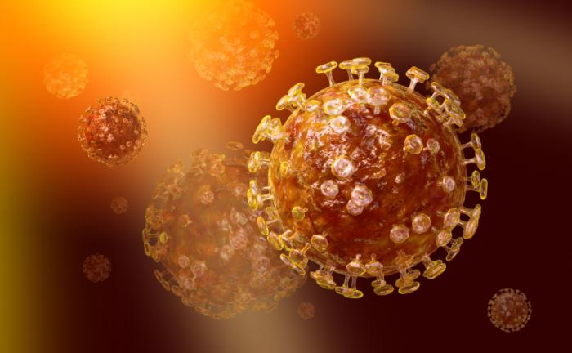
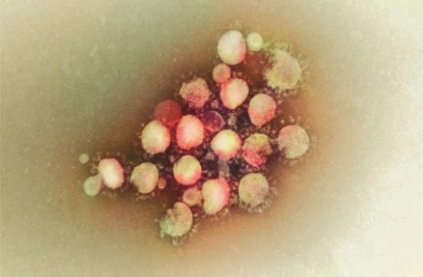
Fig.-1 Coronavirus Family

MERS-CoV is a novel coronavirus from the genus Betacoronavirus, with mild and non-specific symptoms which includes high fever, cough, diarrhea, vomiting and respiratory tract illness. The first case with this disease was reported in Saudi Arabia in April 2012, and then in September 2012 in Qatar, in two patients with severe Pneumonia ^{[[3]]}. The incubation period is assumed to be 14 days. No antiviral agents and Vaccines are developed for this disease. Only it can be diagnosed with PCR (Polymerase chain reaction) test, respiratory tract samples and blood samples. High mortality rate has been reported with this disease. Now a days, cases with MERS-CoV is being noted majorly in South Korea, as earlier it was being reported maximum in Middle East like Jordan, Saudi Arabia, UAE, Qatar, etc.

PATHOPHYSIOLOGY AND EPIDEMIOLOGY
Novel human coronavirus falls under the subfamily Coronavirinae and lineage C of the genus Betacoronavirus. These species are related to species Tylonycteris bat coronavirus HKU4 and Pipistrellus bat coronavirus HKU5.
Additionally, these recent viruses are more related to the viruses from Vespertilionidae and Nycteridae families which is being seen in insectivorous European and African bats, respectively [[5]].
Novel human coronavirus is distinct from SARS and common cold coronavirus, Egyptian virologist Dr. Ali Mohamed Zaki isolated and identified a previously unknown coronavirus from man’s lung [[4]].
MERS-CoV likely came from an animal source in the Arabian Peninsula. Additionally, MERS-CoV had been found in camels in several countries. So it is possible that some people infected after having contact with camels and then direct or indirect contact played major role. Human to Human transmission and Animal to human transmission is assumed to be the major source for infection. Earlier this transmission was limited to Middle East but now transmission of infection from one area to another are is reported [[6]]. Cases from different countries like England, France, Germany, UK and recently from Korea has been reported. Based on the serological studies, it is also confirmed that this virus is originated from camels and antibodies from camels were tested by Protein microarray by visual neutralization and the sources of milk and meat.

Fig.-2 Transmission of MERS-CoV infection

As the major source of MERS-CoV infection is assumed to be dromedary camels, it is also known as “CAMEL-FLU” or “EMC/2012” [[7]].

SIGNS AND SYMPTOMS:
People who became infected with MERS-CoV, developed severe acute respiratory illness and symptoms are:
- Fever above 100°F, Diarrhea, vomiting
- Cough
- Breath shortness
- Mild respiratory illness
- Fatal attack

On the basis of virological and serological infections, it is assumed that the source of infection is dromedary camels [[10]].
Patients with chronic heart disease, lung disease, diabetes and immunocompromised patients are the most probable victim for this infection [[15]].

Fig.-3 Patient’s chest cardiography ^{[[17]]} | 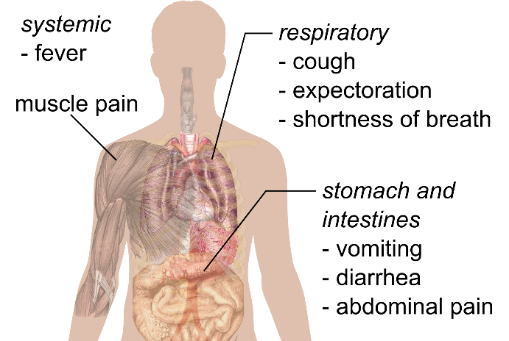  Fig.-4 Symptoms of MERS-CoV

DIAGNOSIS AND TREATMENT
Diagnostic real time reverse-transcription Polymerase chain reaction (RT-PCR) assays are suitable for quantitative and qualitative detection of novel coronavirus.
Moreover, MERS-CoV neutralizing antibodies were found in dromedary camels in Oman but still in human, it is unclear and represents the primary source of human infection. Based on serological assay, which is done by protein microarray technology for specific detection of IgM and IgG antibodies against the emerging human coronavirus hCoV-EMC and the SARS-CoV is also able to diagnose this disease. S1 receptor-binding subunit of the spike protein of hCoV-EMC and SARS-CoV are used as antigens in this assay. The validation of this assay is done using putative cross-reacting sera of patient cohorts exposed to the four common hCoVs and sera from convalescent patients infected with hCoV-EMC or SARS-CoV [[12]].
Based on the cases, incubation period in the laboratory for MERS-CoV is 9-12 days and again it depends on the stage and duration of illness. But it is less than 2 weeks. A team with laboratory technicians, clinical expertise, infection control, social mobilization and animal health specialist is being built and based on the probability factors, possible tests are being done on the patient.
For Laboratory diagnosis, collect the specimen sample, if he patient is MERS-CoV positive. As soon as possible, collect the respiratory specimens like upper respiratory tract sputum, lower respiratory tract sputum within 7 days. Also collect blood samples, stool etc. Make virus detection testing and establish results [[19]].

Treatment
No vaccines-no treatment, Treatment is based on the patient’s clinical condition.
As a precautions, we don’t have to consume raw products related to animals like meat, milk etc.
Oxygen supplement, intensive care unit support and ventilation at most.
Furthermore, some useful antiviral agents for Middle East respiratory syndrome coronavirus (MERS-CoV) [[20],[21],[22]]
- Neutralizing antibody
- Interferons: Interferon alfa, Interferon beta
- HIV protease inhibitors (lopinavir, Nelfinavir), cyclophilin inhibitors (cyclosporine, alisporivir), chloroquine (active in vitro), Mycophenolic acid, nitazoxanide
- Several agents have shown inhibitory effects against MERS-CoV in cell cultures, including mycophenolic acid and cyclosporine A
- Compounds which can inhibit MERS-CoV replication in the low-micromolar range like chloroquine, chlorpromazine, loperamide and lopinavir

Precautions and prevention
Currently there is no antiviral medicines or vaccines are available for this disease. So in this case, Prevention is better than cure [[14]]. In this case, corticosteroids should be avoided as it may result in to serious adverse effects.
- Proper Food hygiene is the key factor. People should consume cooked food or milk rather than having raw milk, raw meat.
- Cover nose and mouth with a tissue while coughing or sneezing, then throw the tissue in the trash.
- Reduce human-to human transmission, while visiting farms, markets, etc., avoid close contacts with animals, particularly camels in affected areas.
- Use appropriate preventive measures like washing hands before and after touching anything
- Don’t come in direct contact with patients. Use gloves, mask, glasses, etc.
- Identify the cause of being sick and if the patient is found positive with probable causes, Start quick treatment and stop further chances of infection. Determine key epidemiology, incubation period, transmission geographical area, and start best possible treatment.

After all these data, if patient is identified with positive MERS-CoV infection,
- Collect basic information of the patient like Name, address, date of birth, age, sex
- Symptoms
- Date of sample collection and Tests results
- Occupation
- Travel History, if he/she had travelled to some Arabian country in past few days
- If he/she had gone through some animal exposure of camels, bats, sheeps, etc. or if he/she had some direct exposure to animal products.
- If he/she was in direct contact with the patient having MERS-CoV infection in hospital or at special facility

DISCUSSION
MERS-CoV is zoonotic virus which is transmitted in to humans via animal-human transmission or sometimes from infected patients to human via human-human transmission. This novel coronavirus is also contagious, so it can pass between humans only with close contact, for example, if one person is handling infectious patient without care or precautions, it can be contagious. Therefore, Many healthcare departments are working on specific guidance to stop spreading this disease.
As Per WHO guidelines, Centre for Disease control and prevention (CDC) and surveillance of Ethiopian Public Health Institute, until 2014, globally 827 cases had been confirmed in several countries with 287 deaths with the fatal rate of 36%. Most affected countries are near the Arabian Peninsula and some travel associated cases from other countries [[1],[14]]. Saudi Arabia is the most affected country until now as in 2012, >85% cases amongst all reported cases, had been reported in Saudi Arabia. And now a day, there are positive a case of this disease has been reported in South Korea also.
As on June 2016, more 24 positive MERS-CoV infections has been reported in Saudi Arabia. And more than 1800 laboratories globally had been registered with positive cases with more than 600 deaths over 27 countries.
No vaccines and Antiviral treatment are available for MERS-CoV, that’s why it is being highly fatal. Only precautions can be the good measures for saving lives.

REFERENCES
- World Health Organization (WHO). Coronavirus infections. Geneva: WHO. [Accessed 2016].
- Available from: http:// www.who.int/emergencies/mers-cov/saudi-arabia-update/en/
- Raoul J., Susan C., Ralph S., Caroline S., “Identification of a novel coronavirus as a cause of severe respiratory disease”, Journal of Virology, 87(14), 2013, 7790-7792.
- Zaki AM, Van Boheemen S, Bestebroer TM, “Isolation of a novel coronavirus from a man with pneumonia in Saudi Arabia”, the New England journal of medicine, 367(19), 2012, 1814-20.
- Annan A., Baldwin HJ, “Human betacoronavirus 2c EMC/2012-related viruses in bats, Ghana and Europe”, emerging infectious disease, 19(3), 2013, 456-9.
- Danielsson N, “Novel coronavirus associated with severe respiratory disease: case definition and public health measure”, Eurosurveillance, 17(39), 2012.
- Centers for Disease control and Prevention, “Information about Middle East Respiratory Syndrome” [Accessed on 2016]
- Available from: https://www.cdc.gov/coronavirus/mers/
- Dr Benoit G, Julien P, “Clinical features and viral diagnosis of two cases of infection with Middle East Respiratory Syndrome coronavirus: a report of nosocomial transmission”, the lancet, 381(9885), 2013, 2265-2272.
- Ethiopian Public Health Institute, “Prevention and Control of Middle East Respiratory Syndrome Coronavirus (MERS-CoV)”, Interim guidelines, July 2014 [Accessed on 2016]
- Available from: http://www.ephi.gov.et/images/pictures/MERS-Coronavirus%20Guideline-Final16%202014.pdf
- Matthew C, Tommy T., Simon J., Anne L., “Full genome deep sequencing and phylogenetic analysis of novel human Betacoronavirus”, Emerging Infectious disease, 19(5), 2013.
- Brian R, Jessica R, Daniel F, David L., Mark A, “Update on the Epidemiology of Middle East Respiratory Syndrome Coronavirus (MERS-CoV) Infection, and Guidance for the Public, Clinicians, and Public Health Authorities — January 2015”, Morbidity and Mortality Weekly report, 64(03), 2015, 61-62.
- Zumla A, David S, Stanley P, “Middle East Respiratory Syndrome”, Lancet, 386(9997), 2015, 995-1007.
- Bushra H, Abdalla M, Arbash H, Alshayeb Z, “An outbreak of Middle East Respiratory Syndrome (MERS) due to coronavirus in Al-Ahssa Region, Saudi Arabia, 2015”, Eastern Mediterranean health Journal, 22(7), 2016, 468-475.
- Arabi M, Ahmed A, Hanan H, Hani N, “Clinical Course and Outcomes of Critically Ill Patients With Middle East Respiratory Syndrome Coronavirus Infection”, Annals of Internal medicines, 160(6), 2014.
- Basem A, Noha B, Haneen Q, Hanadi A, Abeer A, “Patient characteristics infected with Middle East respiratory syndrome coronavirus infection in a tertiary hospital”, Annals of Thoracic medicine, 11(2), 2016, 128-131.
- Mishra B, “Combating the spread of Middle East respiratory syndrome coronavirus: Indian perspective”, Indian journal of medical microbiology, 34(2), 2016, 135-136.
- Reusken CB, Haaqmans BL, Muller MA, Gutierrez C, “Middle East respiratory syndrome coronavirus neutralising serum antibodies in dromedary camels: a comparative serological study”, Lancet Infectious disease, 13(10), 2013, 859-66.
- Petersen E, David S, Stanley P, “Middle East Respiratory Syndrome– advancing the public health and research agenda on MERS- lessons from the South Korea outbreak”, International journal of Infectious disease, 36, 2015, 54-55.
- Dyall J, Coleman CM, Hart BJ, Venkataram T, “Repurposing of clinically developed drugs for treatment of Middle East respiratory syndrome coronavirus infection”, Antimicrobial agents and chemotherapy, 58(8), 2014, 4885-93.
- Chan J, Chan KH, Kao RY, To KK, “Broad-spectrum antivirals for the emerging Middle East respiratory syndrome coronavirus”, The journal of Infections, 67(6), 2013, 606-10.

